Project Title: CALCULATING FAMILY EXPENSES USING SERVICENOW
Team Id:
Team Members: 4
Team Leader: AXLIN PAUL S.V
Team Member 1:ALANJA J.S
Team Member 2:DARWIN J
Team Member 3:ARUN D.T

Problem Statement: Daily and monthly expenses are hard to manage manually, so an automated solution is required.

Objective: To develop a small ServiceNow app for recording daily expenses and autocalculating monthly totals.

Skills: ServiceNow basics, JavaScript, reporting.

TASK INITIATION

Milestone 1:
Activity 1: Setting up ServiceNow Instance
- Sign up for a developer account on the ServiceNow Developer site “https://developer.servicenow.com”.
- Once logged in, navigate to the "Personal Developer Instance" section.
- Click on "Request Instance" to create a new ServiceNow instance.
- Fill out the required information and submit the request.
- You'll receive an email with the instance details once it's ready.
- Log in to your ServiceNow instance using the provided credentials.
- Now you will navigate to the ServiceNow.
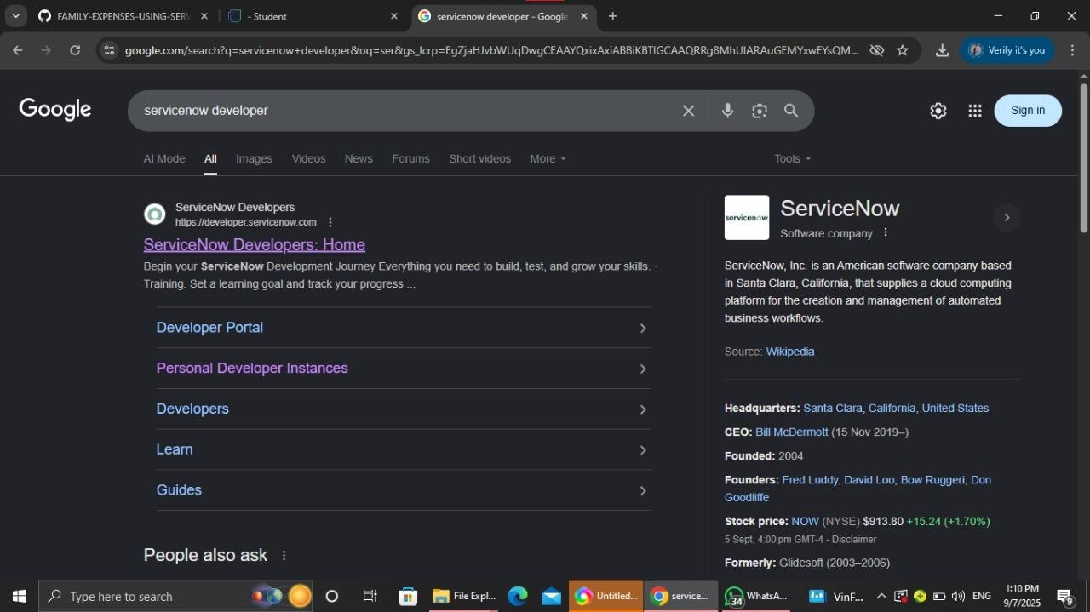

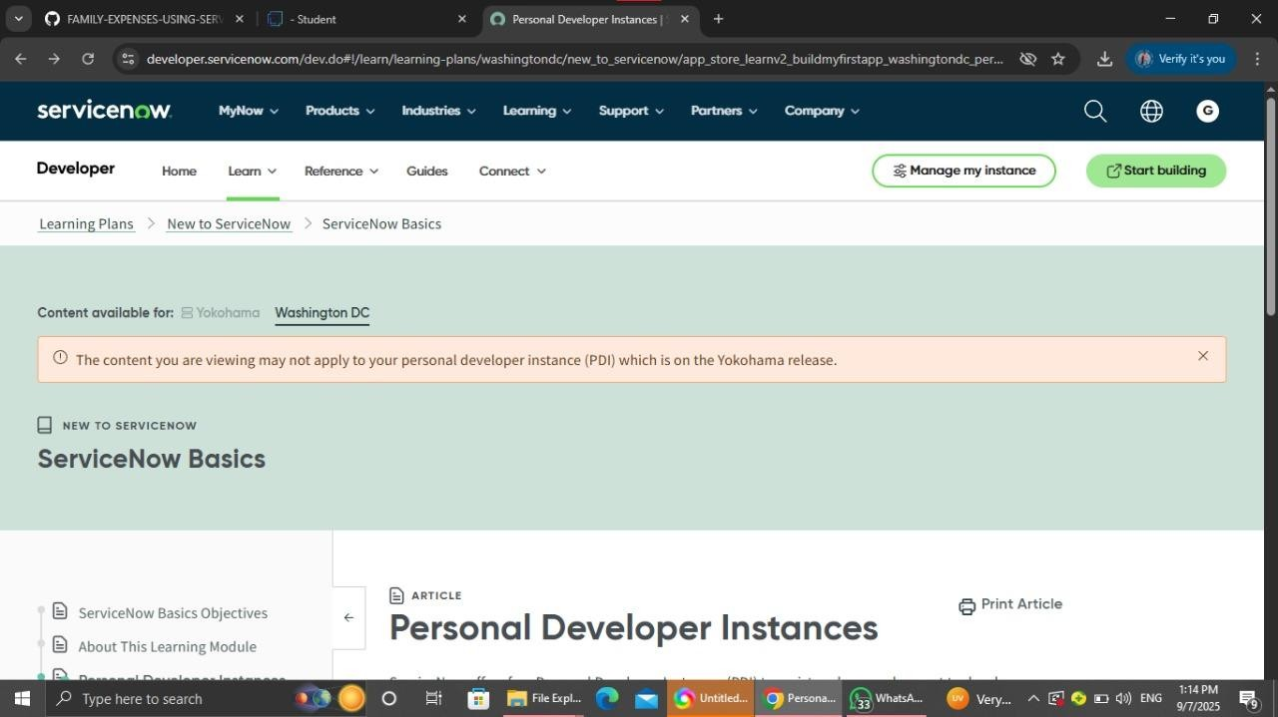
Milestone 2:
Activity 2: Creation of New Update Set
- Go to All >> In the filter search for Local Update set > click on New.
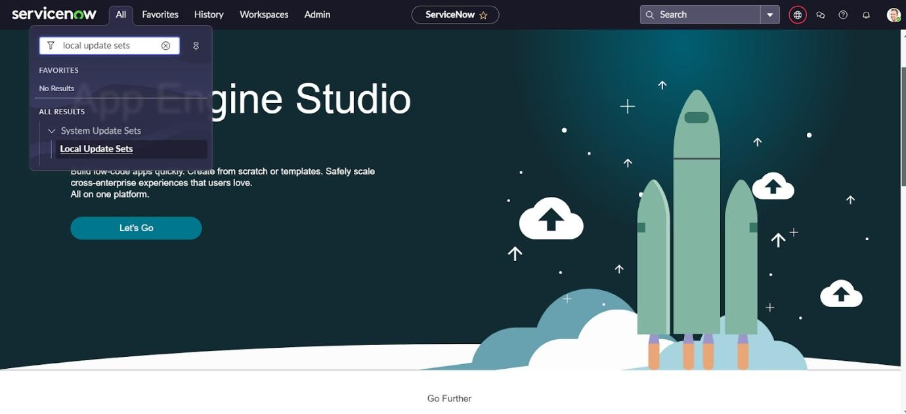
- Enter the Details as:
Name : Family Expenses
- Then click on Submit and Make current.
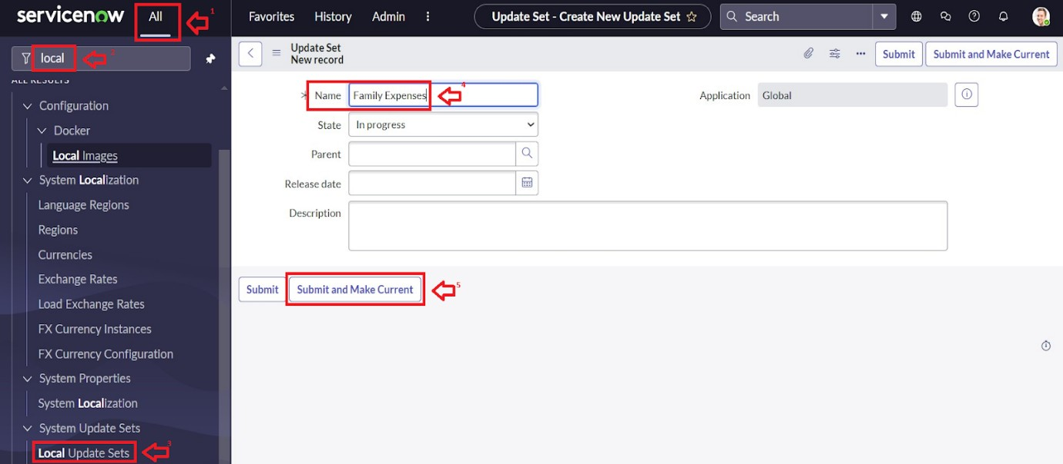
Milestone 3: Creation of tables
Activity 1: Creation of Family Expenses Table
  - Go to All > In the filter search for Tables > click on New.
  - Enter the Details:
Label : Family Expenses
Name : Auto-Populated
New menu name : Family Expenditure
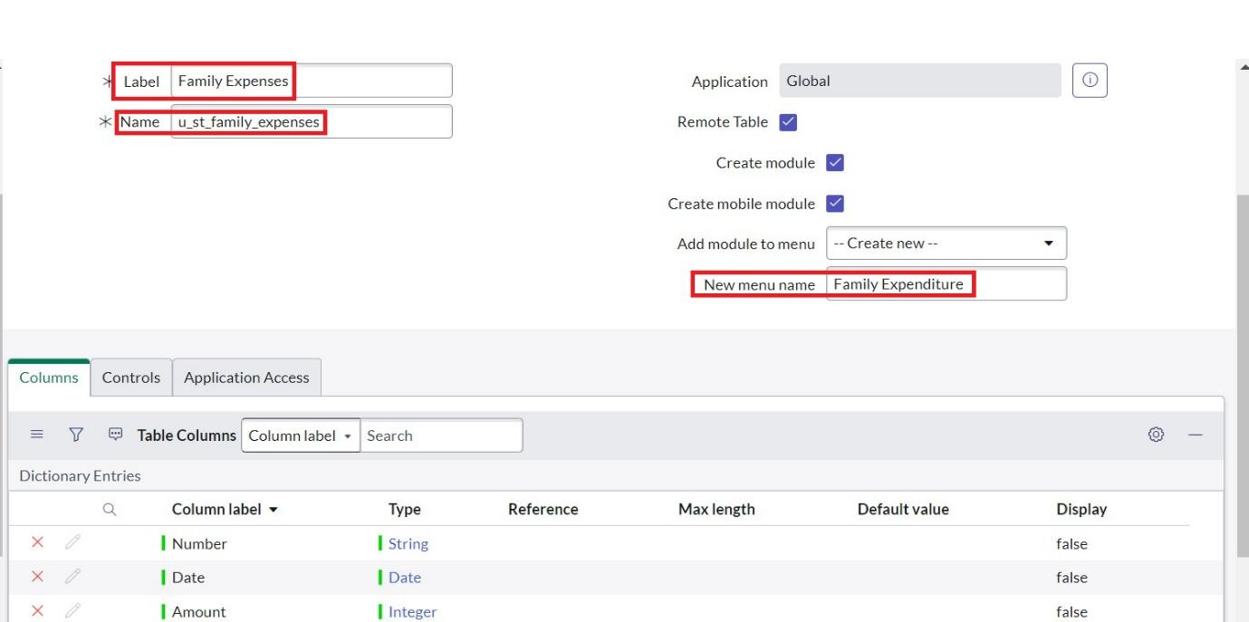
  - Go to the Header and right click there>> click on Save.
Activity2: Creation of Columns(Fields)
  - Near Columns Double click near insert a new row.
  - Give the details as:
Column label : Number
Type : String
  - Double click on insert a new row again
- Give the details as:
Column label : Date
Type : Date
- Double click on insert a new row again
- Give the details as:
Column label : Amount
Type : Integer
- Double click on insert a new row again
- Give the details as:
Column label : Expense Details
Type : String
Max length : 800
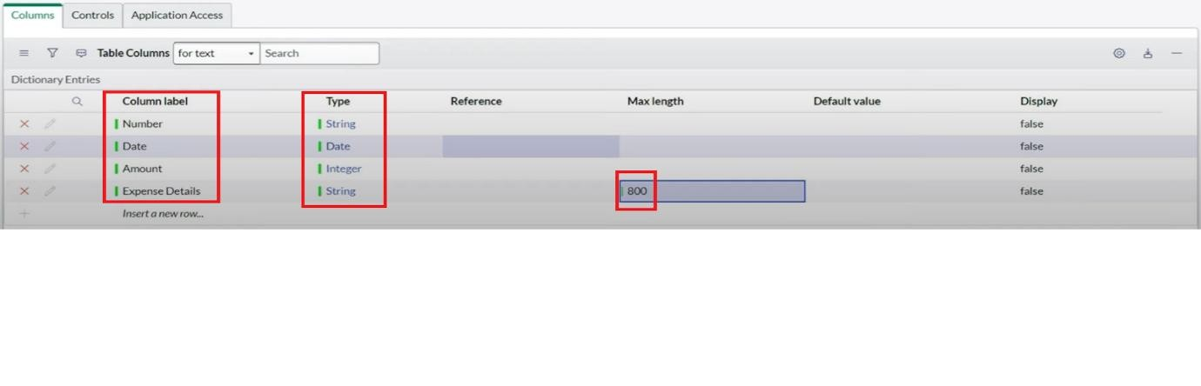
- Go to the Header and right click there>> click on Save.
Activity3: Making Number Field an Auto-Number
  - Double click on the Number Field/Column.
  - Go down and double click on Advanced view
  - In Default Value:
Use dynamic default : check the box
Dynamic default value : Get Next Padded Number
  - Click on Update.
  - 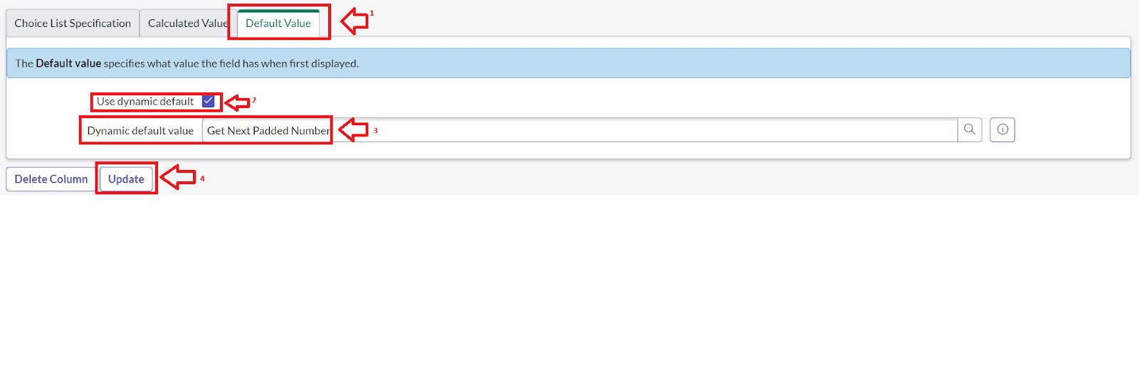
  - Go to All >> In the filter search for Number Maintenance >> select Number Maintenance
  - Click on New.
  - Enter the below Details:
Table : Family Expenses
Prefix : MFE
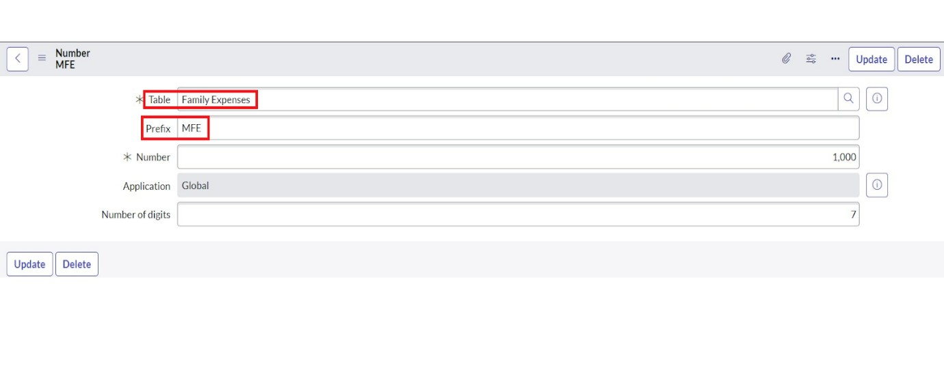
  - Click on Submit.
Activity4: Configure the Form
    - Go to All >> In the filter search for Family Expenses >> Open Family Expenses
    - Click on New
    - Go to the Header and right click there>> click on Configure >> Select Form Design 4. Customize or Drag Drop the form as per your requirement.
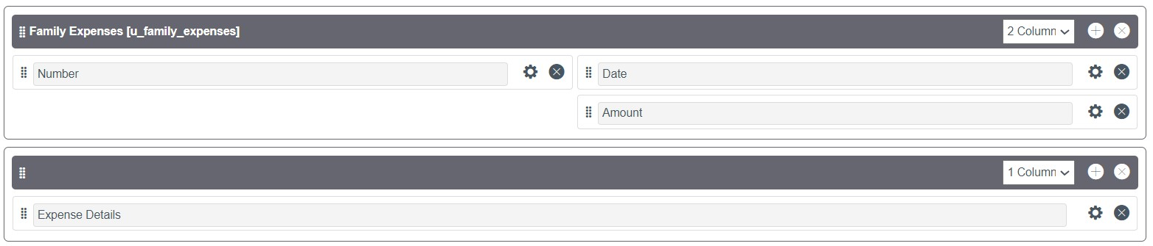
- Make Number Read-Only Field by clicking on the gear icon and checking Read-Only
- Make Date, Amount Mandatory Field by clicking on the gear icon and checking Mandatory 7. Click on Save.
Milestone4:
Activity1: Creation of Daily Expenses Table
    - Go to All > In the filter search for Tables > click on New.
    - Enter the Details:
Label : Daily Expenses
Name : Auto-Populated
Add Module to menu : Family Expenditure
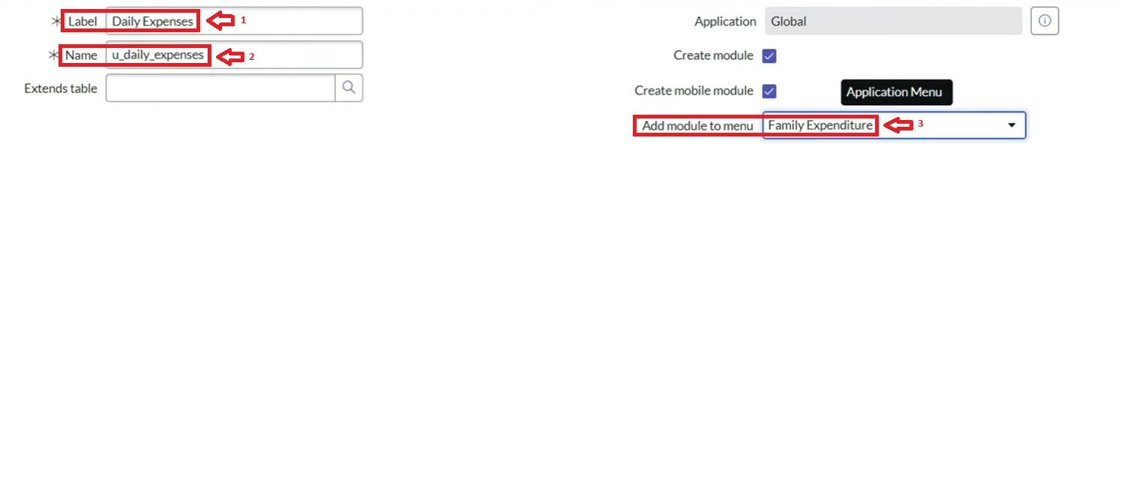
3.Go to the Header and right click there>> click on Save.

Activity2: Creation of Columns(Fields)
  - Near Columns Double click near insert a new row.
  - Give the details as:
Column label : Number
Type : String
  - Double click on insert a new row again
  - Give the details as:
Column label : Date
Type : Date
  - Double click on insert a new row again
  - Give the details as:
Column label : Expense
Type : Integer
- Double click on insert a new row again
- Give the details as:
Column label : Family Member Name
Type : Reference
Max length : 800
- Double click on insert a new row again
- Give the details as:
Column label : Comments
Type : String
Max length : 800

- Go to the Header and right click there>> click on Save.
- 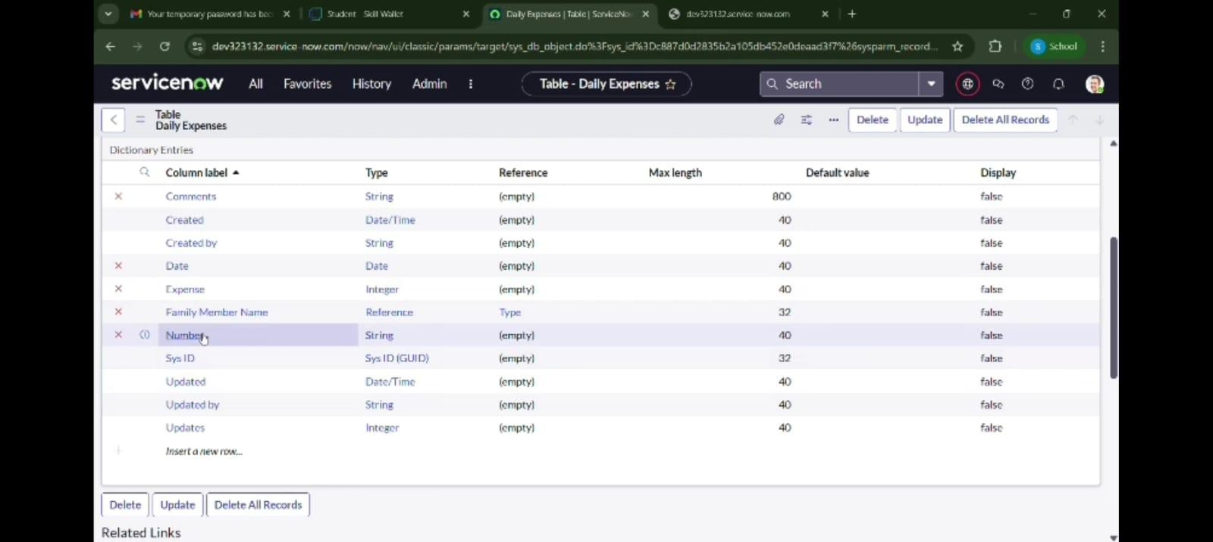
Activity3: Making Number Field an Auto-Number
  - Double click on the Number Field/Column.
  - Go down and double click on Advanced view
  - In Default Value:
Use dynamic default : check the box
Dynamic default value : Get Next Padded Number
  - Click on Update.
  - Go to All >> In the filter search for Number Maintenance >> select
Number Maintenance
  - Click on New.
  - Enter the below Details:
Table : Daily Expenses
Prefix : DFE
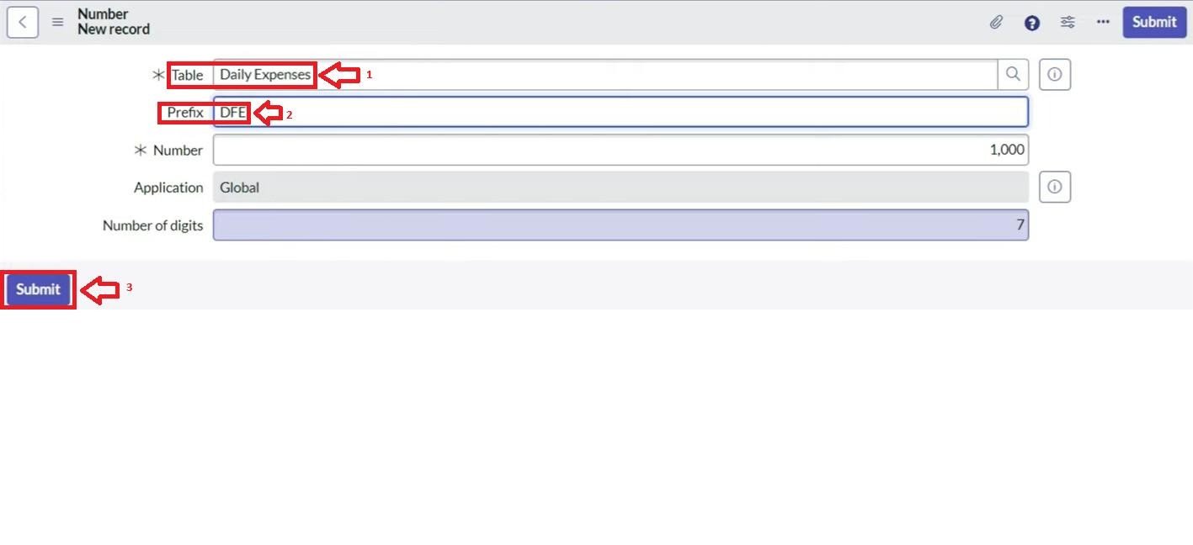
  - Click on Submit.
Activity4: Configure the Form
  - Go to All >> In the filter search for Daily Expenses >> Open Daily Expenses
  - Click on New
  - Go to the Header and right click there>> click on Configure >> Select Form Design
  - Customize or Drag Drop the form as per your requirement.
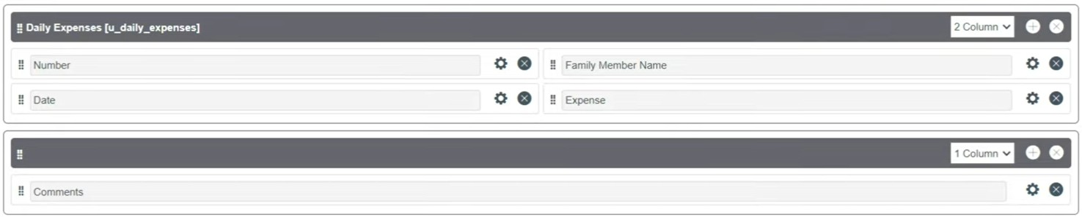
  - Make Number Read-Only Field by clicking on the gear icon and checking Read-Only
  - Make Date, Family Member Name Mandatory Field by clicking on the gear icon and checking Mandatory
  - Click on Save.
Milestone5:
Activity1: Creation of Relationship between Family Expenses and Daily
Expenses tables
  - Go to All >> In the filter search for Relationships >> Open Relationships
  - Click on New.
  - Enter the details:
Name : Daily Expenses
Applies to table : Select Family Expenses
Daily Expenses : Select Daily Expenses
  - Click Save.
Milestone6:
Activity1: Configuring Related List on Family Expenses
    - Go to All >> In the filter search for Family Expenses >> Open Family Expenses
    - Click on New
    - Go to the Header and right click there>> click on Configure >> Select
Related Lists
    - Add Daily Expenses to the Selected Area.
    - Click on Save
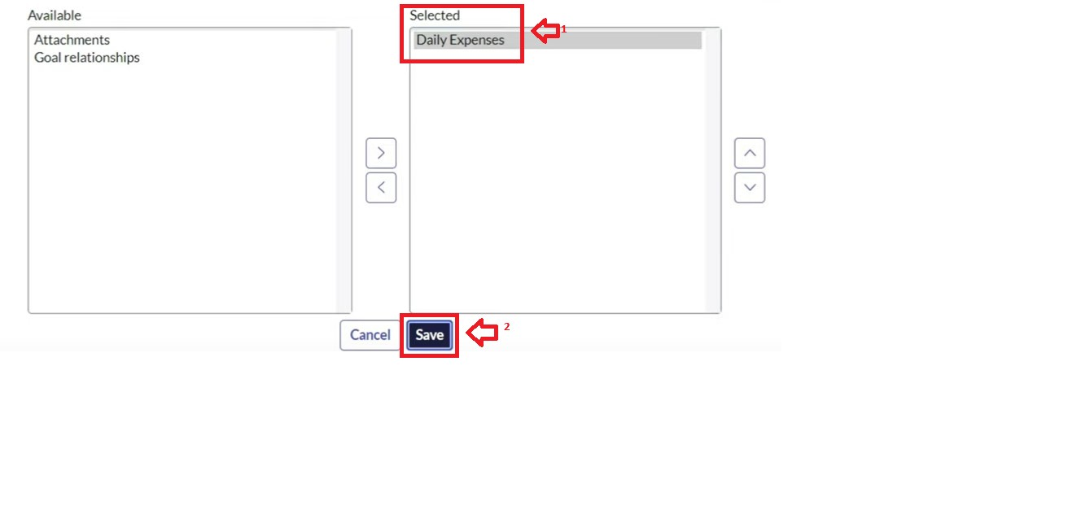
Milestone7:
Activity1: Creation of Business Rules
  - Go to All >> In the filter search for Business Rules.
  - Under System Definition Select Business Rules then click on New.
  - Enter the Details:
Name : Family Expenses BR
Table : Select Daily Expenses
Check Advanced
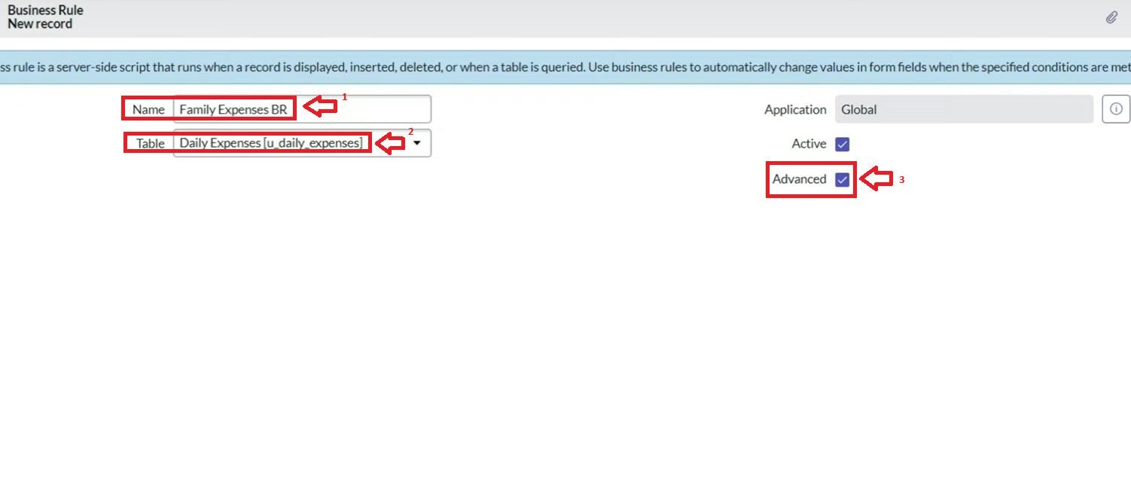
  - In when to run Check Insert and Update
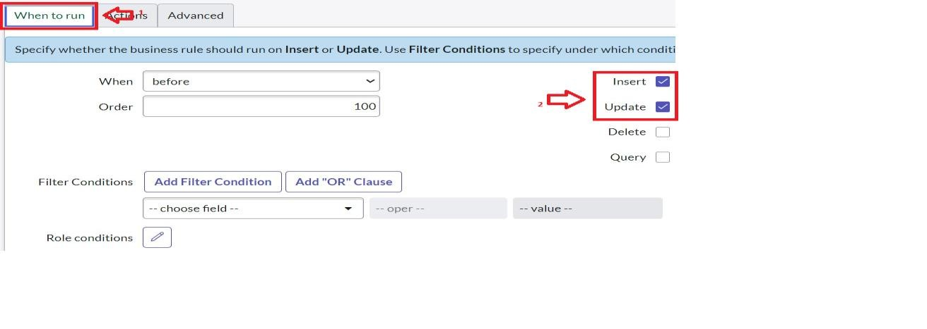
  - In Advance(we write the code): Write the below code >>

(function executeRule(current, previous /*null when async*/) {

var FamilyExpenses = new GlideRecord('u_family_expenses');
FamilyExpenses.addQuery('u_date',current.u_date); FamilyExpenses.query(); if(FamilyExpenses.next())
{
FamilyExpenses.u_amount += current.u_expense;
FamilyExpenses.u_expense_details +=
">"+current.u_comments+":"+"Rs."+current.u_expense+"/-";
FamilyExpenses.update();
}
else
{
var NewFamilyExpenses = new GlideRecord('u_family_expenses');
NewFamilyExpenses.u_date = current.u_date;
NewFamilyExpenses.u_amount = current.u_expense;
NewFamilyExpenses.u_expense_details +=
">"+current.u_comments+":"+"Rs."+current.u_expense+"/-";
NewFamilyExpenses.insert();
}

})(current, previous);

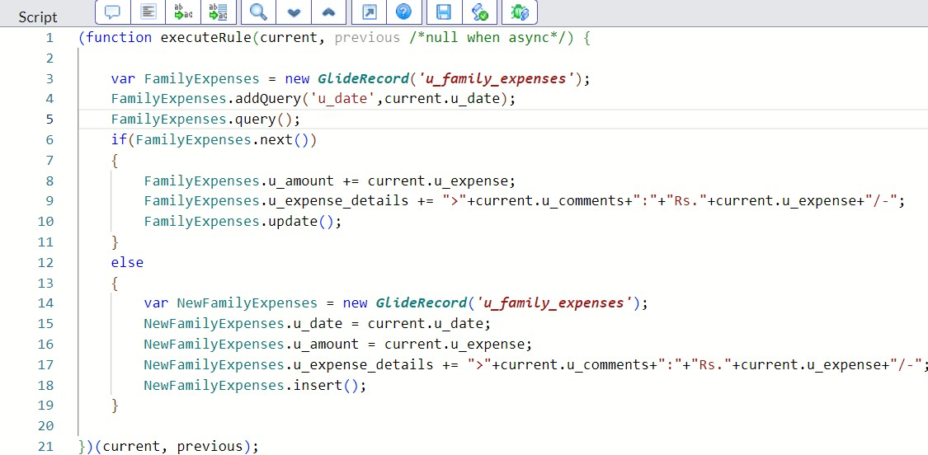

6. Go to the Header and right click there>> click on Save.
Milestone8:
Activity1:
Configure the Relationship
- Go to All >> In the filter search for Relationships >> Open Relationships.
- In that, open Daily Expenses Relationship.
- For Applies to table : Select Family Expenses.
- In Query with : write the below Query.

(function refineQuery(current, parent) {

// Add your code here, such as current.addQuery(field, value); current.addQuery('u_date',parent.u_date);
current.query();

})(current, parent);

- Click on Update.

